Summary
The APP development sample contains the following parts:
- Get token
- Subscribe
- Receive AMQP message
- Unsubscribe
SVA
Get token
Subscribe
Receive AMQP message
Unsubscribe

Get token
Requirement:
OS runing the sample should have curl installed
You can check by running curl in console:
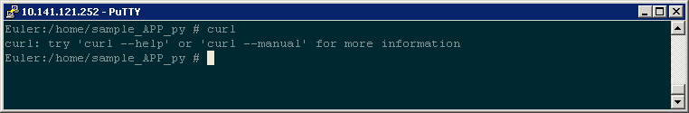
Or, you can install it by reference: http://curl.haxx.se/
Usage:
get_token.py ip app_name pwd
Note:
ip/app_name/pwd should coordinate with MML command ADD APP
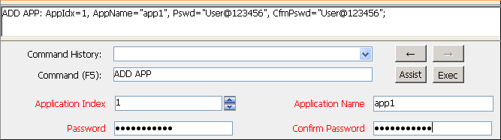
Output:
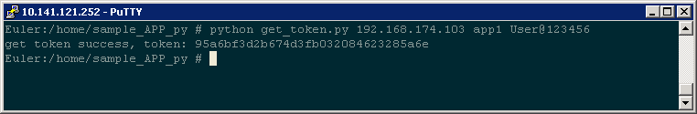

Subscribe
Requirement:
you have got a token by 1. Get token
Usage:
subscribe.py ip app_name token
Output:
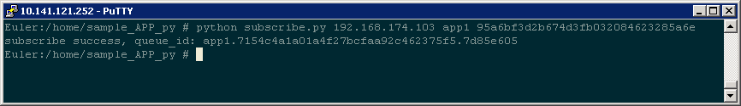
Note:
You can use optional parameter a to subscribe an anonymous topic：
subscribe.py ip app_name token a

Receive AMQP message
Requirement:
- Folder mllib ssl_cert_file and qpid should be placed at the same path with MQReceiver.py
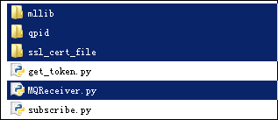
- Python running the sample shoud support ssl
- you have got a queue_id by 2 Subscribe
Usage:
MQReceiver.py app_name ip port queue_id
Output:
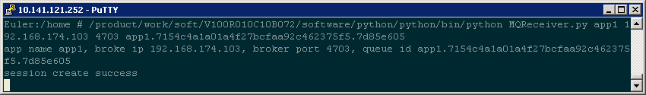

Messages in broker bound to queue_id will shown in console:
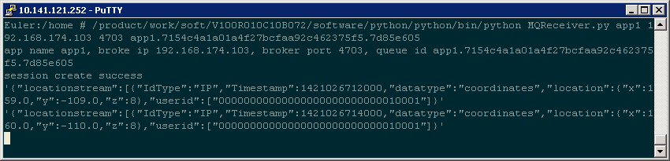
Use 4. unsubscribe to terminate the receiver.

Unsubscribe
Requirement:
you have got a token by 1. Get token
Usage:
unsubscribe.py ip app_name token
Output:
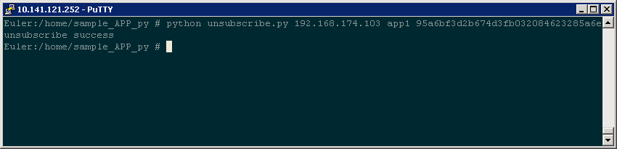
Note:
You can use optional parameter a to unsubscribe an anonymous topic：
unsubscribe.py ip app_name token a

